There should be game changing in global cancer care, via science
-I-
Dear colleagues,
For the sake of millions of cancer patients, for the sake of scientific progress and implementing better value science and patient care, for the sake of lessening the financial burden on the societies and patients and for more flourishing and marked expansion of markets of the health industries in the real world.
There should be game changing in global cancer care, via science.
• Along the last 3 decades - and still – despite of conferences, reports, very respectable international organizations and cancer societies in which we personally horned to contribute actively in many of them for years - In addition to commissions, committees, agendas, programs, summits, important political declarations and initiatives, the gap between the required cancer care and the accessible and the affordable care was widen. It is a waste of time to dispute that. It is a fact. (If you have contrary data, then kindly please send).
• There is no convincing evidence that the needs and the gap will not increase in the upcoming 5 then 10 years. (If any will have a true measured reduction in the gap and NOT some more nice plans or declarations, then, please kindly inform us. Deepest thanks)
- The problem is not in all-respectable players, but in the game
Inspiring from this picture, it could resemble the situation if we continue as we are in the issue of affordability of better value cancer care in the world. Unless there are changes in the game, the affordability of cancer care is going down…going down…going down! SOS…. SOS!

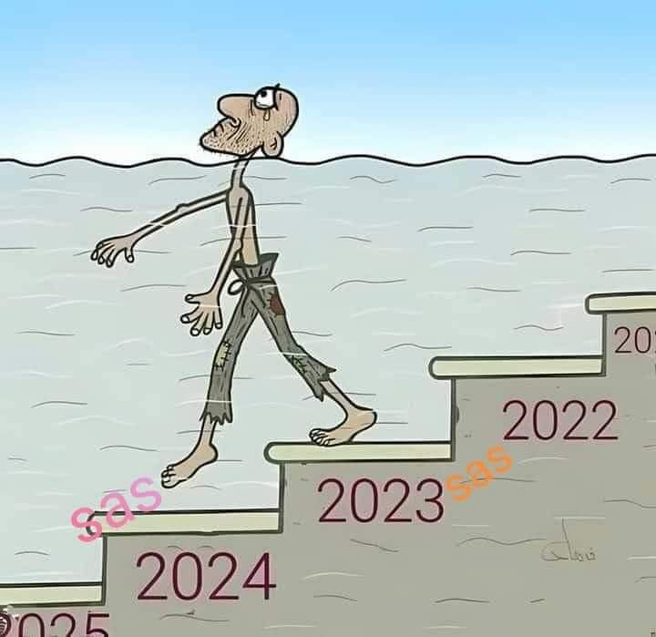
Our Question: Is it possible in the real world via scientific studies, implementing science to increase affordability of better value oncology care in the real world? Answer: YES…YES…. YES!
Ladies and gentlemen, the role of scientists, researchers and oncologists in the front line of patient care is not just to complain of shortage of care, lack of equity, disparities, repeated description of tragedies, or to present pleas to policy makers and politicians who should be aware of all, some sessions in conferences or summits or some more thousands of publications about disparities and Equity. But, to search for what could improve the problems via hundreds of already existing -but unfortunately omitted- scientific avenues published by many authors and to stimulate a big movement of unlimited number of research and studies focused on how to lessen the problem of lack of affordability of better value care in the real world.
“Approaching Global Oncology. The win-win model” https://iopscience.iop.org/book/edit/978-0-7503-3075-6 (Welcome to the first chapter and the book summary, in the front matter are free online).
"There should be game changing in global cancer care, via science" It is stated by Ahmed Elzawawy , but , it is inspired from many of you , from all the discussions and collaborative work with distinguished colleagues in many organizations and societies along the last 40 years” and from all the distinguished leaders and faculty of the win-win initiative www.icedoc.org & www.icedoc.website
Kindly go through this message and kindly spread the message -on your behalf- to all your colleagues, networks and stakeholders. There is a great need for all players and efforts of all initiatives, organizations, societies and institutions.
Please feel free to add words on your behalf. Be a game changer in global cancer care. Raise the flag and lead
If you are not registered yet, then welcome and please register to The Global Oncology-Implementing Science Program GOIS, GO-U. It is free. Click: https://icedoc.website/cms/login/index.php It is a forum for all. Collaborating and not replacing. then click on: register, fill the form and submit it. Welcome.
-Link to video of President of the series ASCO-GOIS International Webinars: Prof. Robin Zon, ASCO President 2024-2025. Welcome Note to the ASCO-GOIS Webinars (duration 3 minutes) https://youtu.be/0eUPIWvnejg
Going forward in fruitful cooperation to serve science, human beings with cancer and colleagues regardless where they are around the globe
Sincerely,
Ahmed
Prof. Ahmed Elzawawy, MD, PhD
e-mail worldcooperation@gmail.com Webs: www.icedoc.website & www.icedoc.org
Chair, The win-win Initiative, & Co-founder, Chair, Board of Directors of Global Oncology-Implementing Science (GOIS) Program, Global Oncology University -GO-U www.icedoc.website & www.gois.website
& Founder, President of ICEDOC & ICEDOC’s Experts in Cancer Without Borders www.icedoc.org
& Past President of AORTIC (African Organization for Research and Training in Cancer)
Professor of Clinical Oncology, Suez Canal University, Ismailia and Chairman of Alsoliman Radiation and Clinical Oncology Center, Port Said, Egypt.
GOIS program, GO-U 2023-2024 ( open access) : https://icedoc.website/GOIS_Program_2023-2024.pdf & Our book “ Approaching Global Oncology. The win-win model https://iopscience.iop.org/book/edit/978-0-7503-3075-6 (The first chapter and the front matter , book summary are free online).
========================================================
-II-
A Call to Actions.

Hunger, Health and Cancer Care.

To All,

It is "A Call to Effective Actions". Be the voice of more than one Billion of human beings in the world who are in need of your voice.

At present in 2025, in this part, we present short introductory points for the video of November 2021 entitled “Hunger, Health and Cancer Care
I'll be grateful if you listen to it (Duration 12'58'') https://youtu.be/kAzlTBUovYo
Since that time -with the exception of changes in names of political leaders- the tragic problem of hunger has aggravated. To everyone in the world, please remember that more than one billion human beings are going to bed tonight without food. Moreover, at least 2 billion human beings are suffering from malnutrition.
- We stress that in fact there is enough food for all human beings in our plant. Hence the huge problem of hunger and malnutrition needs serious and true will, many scientific, smart and new economic approaches, with the consideration of the interests and incentives of all parties.
In addition to the above we cite here few examples of many new scientific approaches:
- The growing scope of precision farming and the future of agriculture:
Artificial intelligence and machine learning (AI/ML) to make smarter agriculture decisions
- The Scientific development of fish farming as the examples of China, Norway and Chile.
- We don’t advocate for meat production from other sources like from small creatures, but, the new progress in lab synthetic meat, if it becomes cheap, nutritional, tasty and accepted by consumers, it could be a last resort in some conditions.
To every cousin on this planet, don’t underestimate the power of your voice. Please be an ambassador and please spread this message and video with words from you. There is no excuse to not to consider health and affordability of better value cancer care among priorities because of hunger and other problems. Contrary to belief, in fact, food would be more than enough! Hoping that with your all voices, the world would be more human and civilized.
The win-win scientific international initiative is a movement, we don’t ask you for donations or charity. The initiative is a message of love for all in the world - not in romantic words or slogans or wishes, but it is expressed into a call for global effective scientific actions that consider the interests of all stakeholders in the real world. The initiative belongs to all and surely to you too. It needs all players. Note: The focus of the win-win scientific initiative is on the need for game changing in global oncology in order to shorten the gap in affordability of better value care. Hence, there is a need for unlimited numbers of focused scientific studies and smart approaches. But it is important to highlight “To consider that global goal as one of the feasible priorities via science”.
Going forward in fruitful cooperation to serve science, millions of human beings with cancer and colleagues regardless where they are around the globe
Sincerely,
Ahmed
Prof. Ahmed Elzawawy, MD, PhD
e-mail worldcooperation@gmail.com Webs: www.icedoc.website & www.icedoc.org
Chair, The win-win Initiative, & Co-founder, Chair, Board of Directors of Global Oncology-Implementing Science (GOIS) Program, Global Oncology University -GO-U www.icedoc.website & www.gois.website , registration is free for all , click: https://icedoc.website/cms/login/index.php
& Founder, President of ICEDOC & ICEDOC’s Experts in Cancer Without Borders www.icedoc.org
& Past President of AORTIC (African Organization for Research and Training in Cancer)
Professor of Clinical Oncology, Suez Canal University, Ismailia and Chairman of Alsoliman Radiation and Clinical Oncology Center, Port Said, Egypt .
GOIS program, GO-U 2023-2024 ( open access) : https://icedoc.website/GOIS_Program_2023-2024.pdf & Our book “ Approaching Global Oncology. The win-win model https://iopscience.iop.org/book/edit/978-0-7503-3075-6 (The first chapter and the front matter, book summary are free online).

